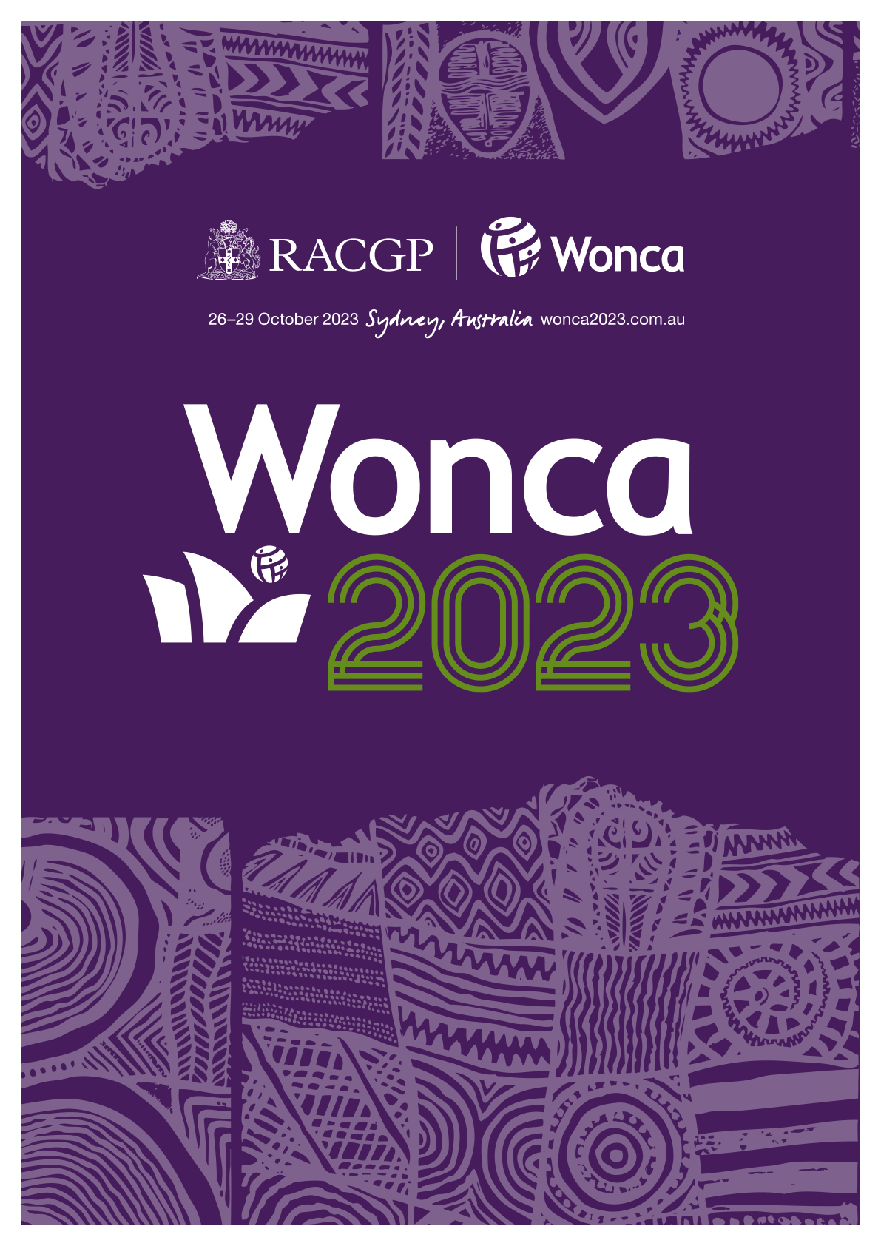

Please use this Word document to draft your submission, then copy / paste into the Informative submission portal

Title and type

Presentation title
Please enter the title of your presentation using sentence case eg "My abstract title: An exploration of sentence structure".
Abbreviations may be used in the title, provided the name in full is outlined in the body of the presentation overview.
Click or tap here to enter text.

Presentation style
Please review the presentation style descriptions
Choose an item.

Streams and themes(s)

Streams
To assist us with reviewing, please select a stream that your presentation best aligns to:
Choose an item.

WONCA groups
WONCA has a number of Working Parties (WP) and Special Interest Groups (SIGs) that work to progress specific areas of interest to WONCA and its members around the globe. Over the years they have carried out groundbreaking studies and research and have produced a variety of important publications.
To assist attendees to navigate the program, presentations will be categorised based on these Working Parties (WP) and Special Interest Groups (SIGs). Choose one or more WONCA groups that your submission would be relevant to:

☐Adolescent care
☐Ageing
☐Cancer
☐Complexities in health
☐Education
☐eHealth
☐Emergency medicine
☐Emerging practice models for family medicine
☐Environment
☐Ethical issues
☐Family violence
☐Genetics
☐Global point of care testing
☐Health equity
☐Indigenous health issues
☐International health
☐LGBTQ health
☐Mental health
☐Migrant care
☐Minority groups health issues
☐Non-communicable diseases
☐Other
☐Palliative care
☐Quality and safety
☐Quaternary prevention and over-medicalisation
☐Research
☐Rural practice
☐Travel medicine
☐Women and family medicine
☐Worker’s health
☐Young adult care

Presenters

Author affiliation(s)
In academic publishing, affiliation is the place (institution) at which the research was conducted and reported/written about. This may be a university or your practice, and you may have more than one.
Please provide the following details for each presenter(s) affiliation(s):
- Affiliation name eg University of Affiliation
- Country eg Antarctica

Author(s)
Authors should be restricted to anyone who has/will directly contribute to writing the abstract, preparing or delivering the presentation. For large, collaborative projects additional contributors should be acknowledged in the presentation (if it is accepted).
Please provide the following details for each submission author:
- First name eg Jo
- Last name eg Citizen
- Please use the tick box to indicate the presenter(s) will be presenting this submission in person at WONCA 2023.
Should your submission be accepted, the presenter(s) you have identified as presenting will be contacted using the details you have provided.
- Email address eg jocitizen@email.com
- Add the number(s) associated with the affiliation(s), separated only by a comma eg 1,2

Presentation content

Abstract summary
Please include aim, content, and goals (max. 300 words). Review the submission guidelines
Click or tap here to enter text.

Learning objectives*
In dot points, please provide three (3) key messages attendees will take away from your presentation.
eg At the conclusion of my presentation attendees will take away
1. key message
2. key message
3. key message
Click or tap here to enter text.

Additional information

Assumed knowledge of attendee
What is the attendees' assumed knowledge/experience?
Choose an item.

Keyword suggestions
Presentation topics assist us with program scheduling and ensure similar topics are not presented at the same time.
Please provide three (3) keywords or short phrases that capture the essence and are appropriate to your submission. Separate each keyword with commas eg GP trainees, communication skills, serious mental illness.
We will then compile and use submitted keywords to form the session themes for the conference.
Click or tap here to enter text.

Conflict(s) of interest
In the interest of transparency, we ask you to disclose all relationships/activities/interests that are related to the content of your submission. “Related” means any relation with for-profit or not-for-profit third parties whose interests may be affected by the content of the submission. For example, if your submission pertains to the epidemiology of hypertension, you should declare all relationships with manufacturers of antihypertensive medication, even if that medication is not mentioned in the submission. Disclosure represents a commitment to transparency and does not necessarily indicate a bias.
If you're unsure of what to declare please visit the International Committee of Medical Journal Editors (ICMJE) website.
Choose an item.

Conflict(s) of interest disclosure
Click or tap here to enter text.

