Activity 5 – Implementing your new mixed billing policy
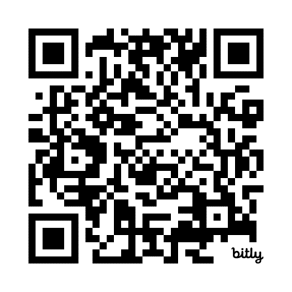
Task 3 – Dealing with unhappy or angry patients
Scan the QR code to log your activity

Ensure you keep adequate records of your activity as you may be audited by the RACGP or Medical Board of Australia (MBA). The MBA requires evidence of your annual CPD activities to be retained for three years. See evidence guide here.
As this is a self-directed activity, your workbook and audit activities will not be assessed or used against you in any way.

In implementing your new billing policy, there may be some patients who are unhappy with the change in billing policy and demand that they are bulk billed. Some patients who are used to being bulk billed may not accept your new policy and may become upset or even angry during their consultation. Good communication skills are vital to reduce and manage any escalation.
In such situations, you may wish to remind the patient of the quality of care that they are receiving and that the cost of delivering general practice services has increased significantly. You may also need to explain to patients that the Medicare rebate is the patient’s rebate and does not fully fund general practice.
The LOWLINE approach has been shown to be useful in situations like these:
- Listen to person to understand what the issue is.
- Offer reflective comments to show that you have heard what their concerns are.
- Wait for the person to fully express themselves and do not interrupt or rush them.
- Look and maintain appropriate eye contact to connect with the person.
- Incline your head slightly, to show you are listening.
- Nod to confirm that you are listening and have understood.
- Express empathy to show you have understood and remain non-judgment in your response.

Question: How will you respond to a patient who is upset about being charged a private fee?

Question: What are some of the communication techniques you can use to manage a situation where the patient is upset or angry over the change in your billing practice?

