Activity 5 – Implementing your new mixed billing policy

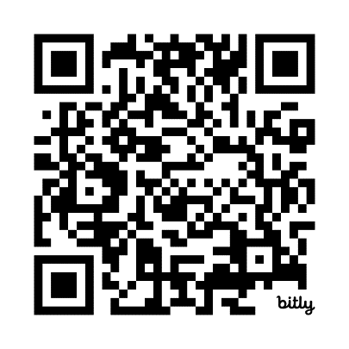
Task 1 – Working with your practice team to implement your new policy
Scan the QR code to log your activity

Ensure you keep adequate records of your activity as you may be audited by the RACGP or Medical Board of Australia (MBA). The MBA requires evidence of your annual CPD activities to be retained for three years. See evidence guide here.
As this is a self-directed activity, your workbook and audit activities will not be assessed or used against you in any way.

It is important that you work closely with your practice team to ensure that your new billing policy is implemented successfully. From the time your patient books their appointment, whether online, over the phone or in-person, to when they arrive at your practice and when they are finally at their consultation, they should already be aware of your new billing policy.
This means that messaging at the reception area and with other members of the practice staff should be consistent throughout.
Question: What steps can you take to ensure that your new fees and billing policy is communicated consistently to your patients?

Question: How can you support the team at your practice to implement your new billing policy?

