Activity 4 – Setting fees and building your fees list
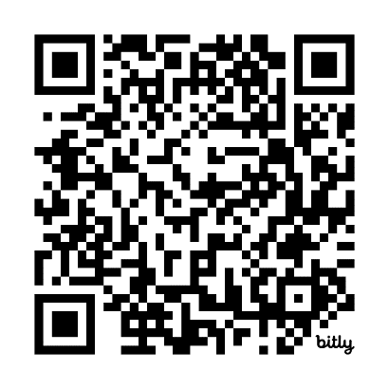
Task 2 – Using the MBS Online tool to create your personalised fee list
Scan the QR code to log your activity

Ensure you keep adequate records of your activity as you may be audited by the RACGP or Medical Board of Australia (MBA). The MBA requires evidence of your annual CPD activities to be retained for three years. See evidence guide here.
As this is a self-directed activity, your workbook and audit activities will not be assessed or used against you in any way.

To determine this your most billed MBS items, you may want to run a billing report from your practice software.
If you have completed Activity 2: Understand your practice costs and identify current billing arrangements, you can consider your patients and services identified in the mini audit.
Question: What are some of your most billed items?

