Activity 4 – Implementing your new mixed billing policy
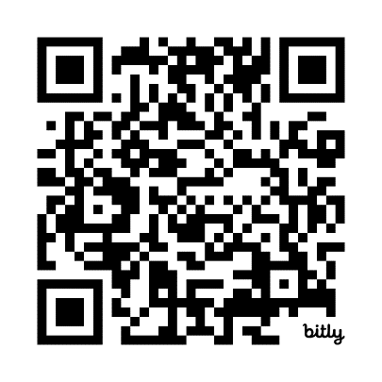
Task 2 – Communicating your new mixed billing policy with your patients
Scan the QR code to log your activity

Ensure you keep adequate records of your activity as you may be audited by the RACGP or Medical Board of Australia (MBA). The MBA requires evidence of your annual CPD activities to be retained for three years. See evidence guide here.
As this is a self-directed activity, your workbook and audit activities will not be assessed or used against you in any way.

Communicating with your patients about your new billing policy is an important part of implementing your new policy. Patient education on billing is a necessary part of the relationship between GPs and their patients. Patients need to be supported to understand why there are out-of-pocket costs associated with their healthcare.
While a large proportion of communication with patients on your new billing policy will occur at a practice level, there will be a need to also communicate with your patients at the consultation level.
Depending on your billing policy, you may need to identify the cohort of patients who are impacted and tailor your communication accordingly. The RACGP resource Discussing fees with your patients provide useful tips for informing patients about fees.
Question: What are some strategies you can use to support the communication of your new billing policy at the consultation level?

Question: What are some of the key messages?

