Activity 2 – Understanding your practice costs and identify current billing arrangements

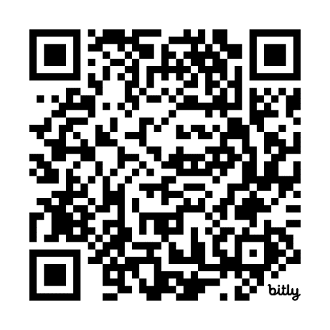
Part 6 – Data analysis
Scan the QR code to log your activity

Ensure you keep adequate records of your activity as you may be audited by the RACGP or Medical Board of Australia (MBA). The MBA requires evidence of your annual CPD activities to be retained for three years. See evidence guide here.
As this is a self-directed activity, your workbook and audit activities will not be assessed or used against you in any way.

Task 6 – Reflective questions
Using the data you collected and analysed in Task 5, reflect on the questions below.
Question 1: Looking back at your data analysis, do the results surprise you?

Question 2: Which areas/services do you think you can bulk bill less?

Question 3: Which areas/services do you think you can privately bill more?

