Activity 2 – Understanding your practice costs and identify current billing arrangements

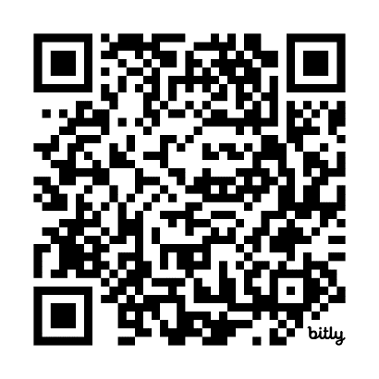
Part 3 – Data analysis
Scan the QR code to log your activity

Ensure you keep adequate records of your activity as you may be audited by the RACGP or Medical Board of Australia (MBA). The MBA requires evidence of your annual CPD activities to be retained for three years. See evidence guide here.

Identifying your current billing arrangements
Do you apply different billing arrangements for different patient groups or services? It is appropriate to evaluate how you are billing various groups of patients and/or services. This can help you determine whether changes could be made to achieve a more sustainable business in a way that you believe is fair for your patients.
To get a more accurate reflection of your billing arrangements, you are encouraged to extract the appropriate data from your practice software.

Task 5 – Collect and analyse data on your current billing arrangements
Use the template below to collect and analyse the data on your current billing arrangements.
 | Patient group / service | Approximate number seen in a typical month | Approximate proportion bulk-billed | Approximate proportion privately billed
Example only | Level A consultations (item 3) | 120 | 70% | 30%
Examples you may want to consider | Level B consultations (item 23)
Examples you may want to consider | Children 16yrs and under
Examples you may want to consider | Concession card holders
Examples you may want to consider | Patients aged 65 years or older
Examples you may want to consider | Patients who identify as Aboriginal and/or Torres Strait Islander
Examples you may want to consider | Patients who do not attract a bulk billing incentive
Examples you may want to consider | After-hours consultations
Examples you may want to consider | Minor procedures
Examples you may want to consider | Telehealth consultations
Examples you may want to consider | General Practitioner Management Plans (GPMPs)
Examples you may want to consider | GP Mental Health Treatment Plans
Examples you may want to consider | Follow-up / recall appointments
Examples you may want to consider | Health Assessments
Examples you may want to consider | Immunisations
Left blank for you to fill in with patient groups or services relevant to your practice

