Activity 2 – Understanding your practice costs and identify current billing arrangements


Part 2 – Data collection
Scan the QR code to log your activity

Ensure you keep adequate records of your activity as you may be audited by the RACGP or Medical Board of Australia (MBA). The MBA requires evidence of your annual CPD activities to be retained for three years. See evidence guide here.
As this is a self-directed activity, your workbook and audit activities will not be assessed or used against you in any way.

Task 4 – Breaking down your breakeven point
Use the RACGP Billing calculator, calculate your average hourly and monthly billings.
In the first tab (Annual income), you can calculate the average hourly billings required to meet your desired income.
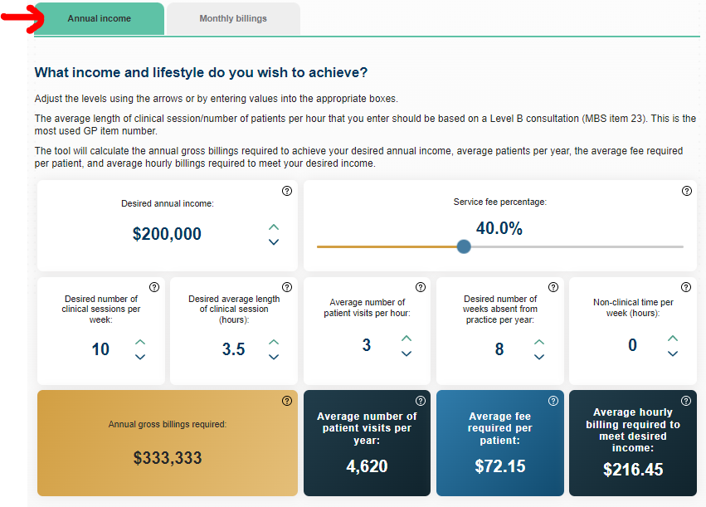
On the second tab of the billing calculator (Monthly billings), enter your typical billing as it currently stands.
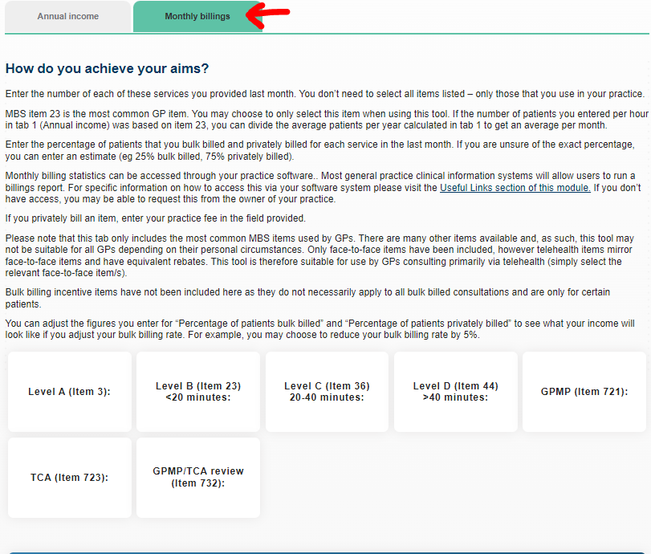
Using the RACGP Billing calculator, calculate the following to determine whether you are meeting your financial goals.
- Average hourly billing
- Predicted annual income

Question: Do your current billings align with your breakeven point?

Question: Are your currently meeting your financial goals?

