Activity 2 – Understanding your practice costs and identify current billing arrangements

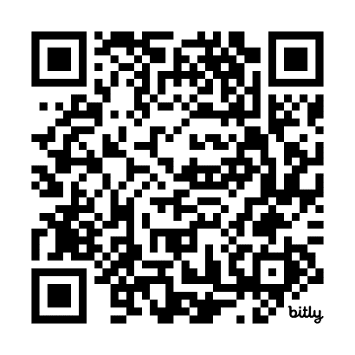
Part 2 – Data collection
Scan the QR code to log your activity

Ensure you keep adequate records of your activity as you may be audited by the RACGP or Medical Board of Australia (MBA). The MBA requires evidence of your annual CPD activities to be retained for three years. See evidence guide here.
As this is a self-directed activity, your workbook and audit activities will not be assessed or used against you in any way.

Task 3 – Identify your breakeven point
Use the RACGP Billing calculator to identify your revenue to help establish your breakeven point.
Question: As an individual GP, this reflects the total income you need to achieve to cover costs and maintain your lifestyle.

Question: As a practice owner, this reflects the total revenue you need to achieve to cover practice costs (including drawing an income for yourself).

