
Activity 1 – Understanding your practice costs and identify current billing arrangements

All tasks
Scan the QR code to log your activity

Ensure you keep adequate records of your activity as you may be audited by the RACGP or Medical Board of Australia (MBA). The MBA requires evidence of your annual CPD activities to be retained for three years. See evidence guide here.
As this is a self-directed activity, your workbook and audit activities will not be assessed or used against you in any way.
Part 1 – Planning and preparation

Task 1 – Collect and identify fixed and non-fixed costs
Use the template below to collect and identify fixed and non-fixed costs associated with delivering general practice services.
 | Fixed costs |  | Non-fixed costs (variable)
Example only | Rent | $110,000 | Medical consumables | $30,000
Example only | Professional costs | $75,000 | Other consumables | $6,500
Example only | Utilities | $10,000 | Staff wages | $250,000
Example only | Building insurance | $15,000

Task 2 – Reflection questions
Use the data collected in Task 1 to answer the questions below.
Question: Identify the 3 highest fixed and non-fixed costs associated with providing care to your community?

Question: What are the top 3 fixed or non-fixed costs that have risen the most for you over past 5 years?

Question 3: What costs could be reduced? How will you go about seeking to reduce these?

Part 2 – Data collection

Task 3 – Identify your breakeven point
Use the RACGP Billing calculator to identify your revenue to help establish your breakeven point.
Question: As an individual GP, this reflects the total income you need to achieve to cover costs and maintain your lifestyle.

Question: As a practice owner, this reflects the total revenue you need to achieve to cover practice costs (including drawing an income for yourself).

Task 4 – Breaking down your breakeven point
Use the RACGP Billing calculator, calculate your average hourly and monthly billings.
In the first tab (Annual income), you can calculate the average hourly billings required to meet your desired income.
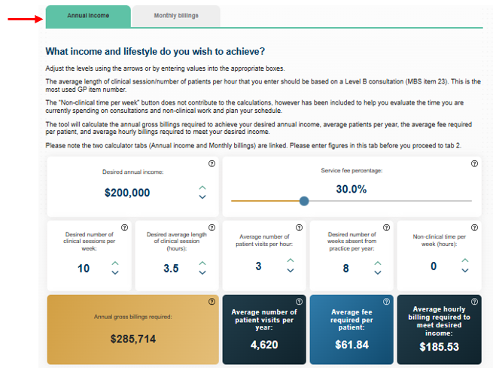

On the second tab of the billing calculator (Monthly billings), enter your typical billing as it currently stands. You can also enter your MMM location to determine the relevant bulk billing incentive.
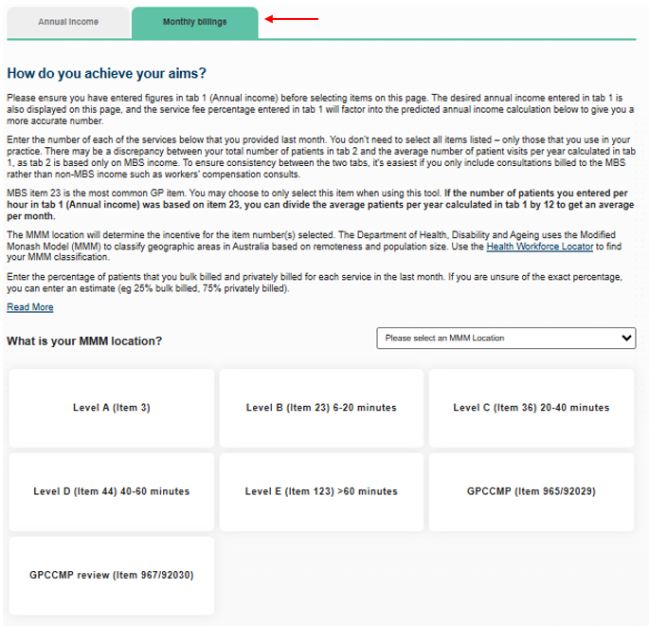
Using the RACGP Billing calculator, calculate the following to determine whether you are meeting your financial goals.
- Average hourly billing
- Predicted annual income

Question: Do your current billings align with your breakeven point?

Question: Are your currently meeting your financial goals?

Part 3 – Data analysis
Identifying your current billing arrangements
Do you apply different billing arrangements for different patient groups or services? It is appropriate to evaluate how you are billing various groups of patients and/or services. This can help you determine whether changes could be made to achieve a more sustainable business in a way that you believe is fair for your patients.
To get a more accurate reflection of your billing arrangements, you are encouraged to extract the appropriate data from your practice software.

Task 5 – Collect and analyse data on your current billing arrangements
Use the template below to collect and analyse the data on your current billing arrangements.
 | Patient group / service | Approximate number seen in a typical month | Approximate proportion bulk-billed | Approximate proportion privately billed
Example only | Level A consultations (item 3) | 120 | 70% | 30%
Examples you may want to consider | Level B consultations (item 23)
Examples you may want to consider | Children 16yrs and under
Examples you may want to consider | Concession card holders
Examples you may want to consider | Patients aged 65 years or older
Examples you may want to consider | Patients who identify as Aboriginal and/or Torres Strait Islander
Examples you may want to consider | Patients who do not attract a bulk billing incentive
Examples you may want to consider | After-hours consultations
Examples you may want to consider | Minor procedures
Examples you may want to consider | Telehealth consultations
Examples you may want to consider | GP chronic condition management plan (GPCCMP)
Examples you may want to consider | Follow-up / recall appointments
Examples you may want to consider | Health Assessments
Examples you may want to consider | Immunisations
Left blank for you to fill in with patient groups or services relevant to your practice

Task 6 – Reflective questions
Using the data you collected and analysed in Task 5, reflect on the questions below.
Question 1: Looking back at your data analysis, do the results surprise you?

Question 2: Which areas/services do you think you can bulk bill less?

Question 3: Which areas/services do you think you can privately bill more?

